**Powershell-Function**

What is Function?   
A function is a block of code that has a name and it has a property that it is reusable. Like in other programming language we can create function in powershell as well, it is basically groups a number of program statements into a unit and function is given name to it.   
This unit can be invoked from other parts of a program.

**Function Syntax:**

With parameter

**function** **FunctionName** (parameters)

{

#script block

}

Without parameter

**Function** MyFunctionGetTime

{

Get-**Date**

}

To get execute function just give the function name. PS c:\>MyFunctionGetTime   
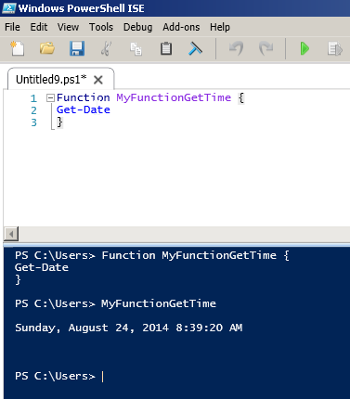   
By use of fuction we can do the script organization. We can reuse the code.   
Use of function give you ability to call script blocks multiple times. 

**function** **Addtion** ([int] $x, [int] $y) {

$z = $x+ $y

#"Function is running"

**return** $z

}

#someFunction (5, 4) --Wrong

$b = someFunction 5 4 --right

$b # sum of tow valies

$z # Default value zero here as it is out of scope